

Mohd. Razia Alangir Banu
MALLAVARPU BALA PRANITHA
2520030051
CSE
CO-5

Case Study Topic: SmartRoute – Intelligent Delivery Route Optimization System

Workdone summary: The SmartRoute system was developed to optimize delivery operations by modeling the transportation network as a weighted graph. Dijkstra’s algorithm was implemented to find the shortest path in graphs with non-negative edge weights, while Bellman-Ford algorithm was used to handle graphs that may contain negative edge weights. The results of both algorithms were analyzed to identify the most efficient delivery routes and improve logistics planning.

Implementation Details
- Delivery locations are represented as vertices in a weighted graph.
- Roads and travel costs are stored as weighted edges.
- Dijkstra’s algorithm is used for fast shortest-path computation.
- Bellman-Ford algorithm is used to handle graphs with negative weights.
- The system compares path costs generated by both algorithms.
- Optimal routes are selected to reduce delivery time and transportation expenses.

Result:
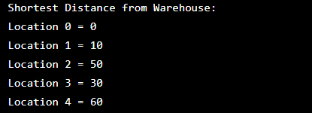
The SmartRoute system successfully computes the shortest delivery routes from the warehouse to all locations using Dijkstra's Algorithm, helping reduce delivery time and transportation costs.

Github Link: https://github.com/balapranithamallavarapu-cmyk/DSA-II-Case-Studies

